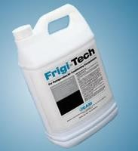

**Frigi-Tech**

**Polarized Refrigeration Oil Supplement**

**Reduce Energy Cost Reduce Friction Extend Equipment Life**

**For Air Conditioning and Refrigeration Compressors**

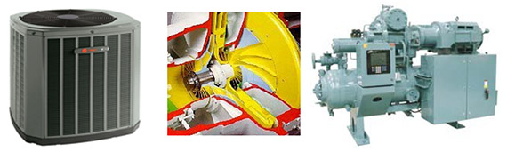

**Frigi-Tech™** is designed for use in refrigeration, air conditioning, chillers, heat pumps and any hermetic or non- hermetically sealed lubrication systems. Frigi-Tech™ will give new life to bearings, seals, and all compressor parts, increase cooling capacity, quiet compressor noise and save electricity.

**Frigi-Tech™** restores the heat exchange and any losses of efficiency by remedying the oil fouling that has occurred. For restoring heat exchanging properties only one treatment is necessary for the life of the system.

**Frigi-Tech™** is compatible with new and old refrigerants as we custom blend to meet manufacturers specifications. Even proven in Ammonia systems.

**Frigi-Tech™** will not void Manufacturers Warranty.

**Oil Fouling Problem in Refrigeration Systems** **& Effects on Heat Transfer Losses**

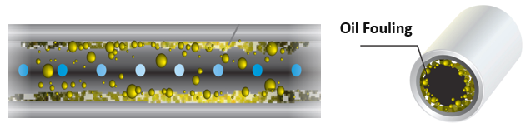

Oil fouling that impedes HVAC system operation and makes compressors work harder, causing higher kilowatt usage.

* 7% Loss after the 1st Year
* 5% after the 2nd Year
* 2% each additional Year

Usually the efficiency degradation will peak between 20 % - 30% *(ASHARE Handbook published )*

**Frigi-Tech products benefits**

Main Benefits Outlook

* Reduction in amperage
* Reduction in total kWh
* Saving Energy by Reducing Compressor Run Time
* Eliminates Oil Fouling From Refrigerant Lines , Restoring Heat Exchanging
* Increases Cooling Capacity
* Reduces Friction of moving Compressor parts during operation as well as start-up
* Extending Life of Parts, Bearings and Seals, relief from Service issues.
* Only One Treatment necessary

Additional Benefits Outlook

* Maintains volumetric capacity
* Reduces excessive heat generation
* Quiets the decibel of Compressor noise during operation
* Major reduction in mechanical failures
* Provides oxidation and corrosion protection
* 2,000,000 USD worldwide insurance coverage

**How Frigi-Tech solve the problem**

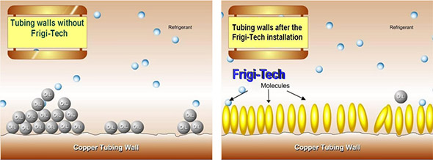

**Oil Fouling effect**

Oil fouling that impedes HVAC system operation and makes compressors work harder, causing higher kilowatt usage.

**After treatment with Frigi-Tech**

Frigi-Tech's polarized molecules bond to the metal inside the system, preventing the insulating build-up of oil which occurs over time due to oil fouling.

**Frigi-Tech Product component**

1. **Anti-Ware additive (A) Contact activate additive & B) Friction activate additive)**

Bond to metal surface and protect against damage during Hydrodynamic lubrication failure.

1. **Oxidation inhibitor**

Preserve oil from oxidized or deteriorate, allowing refrigeration oil to perform at peak level longer and extend oil life.

1. **Corrosion inhibitor**

Protect precision Compressor component from acid.

1. **Surfactant agent**

Reduce foaming and increase Cooling capacity (Foam slow the heat transfer process) and minimize residue Oil film thickness in condenser and evaporator Coils (act as insulator)

1. **Conditioner**

Maintain Elastomer resiliency and pliability from cracking (seal, valve, gasket, hose, pressure relief)

**Frigi-Tech Product Identification**

|  |  |  |  |
| --- | --- | --- | --- |
|  |  | Frigi-Tech Products Types |  |
| Grade | **Type** | **Common Refrigerants** | |
| 9611 | Mineral Oil Blend | HCFC Refrigerants | R-22, R-123, R-11 |
| 9622 | Polyoester Oil Blend | HFC Refrigerants | R-134,R-410,R-404,R-407 |
| 9644 | Alkylbenzene Oil Blend | Interim Refrigerants HCFC Blends | HP-80 R-414 & R-401 |
| 9633 | Low Temp Oil Blend | Low Temperature Mineral Oils | R-22&R-17(Ammonia) |
| 9666 | Polyalklene Glycol Oil lend | HFC R-134A Automotive HVAC systems | |
|  | Custom Blend | Blended to be an exact match to customers brand of oil | |

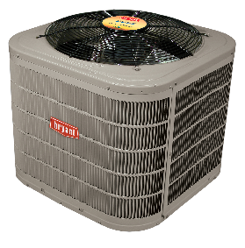 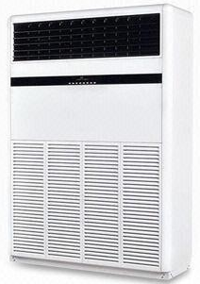 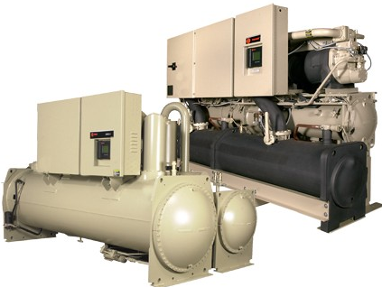

**Frigi-Tech Application**

* Air Conditioners
* Chillers
* Refrigerated Transport
* Freezer / Ice machines
* Heat Pump
* Automobiles

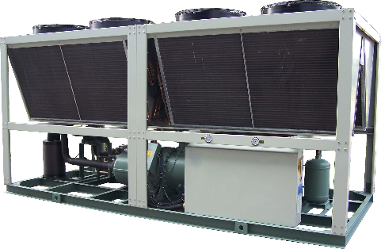 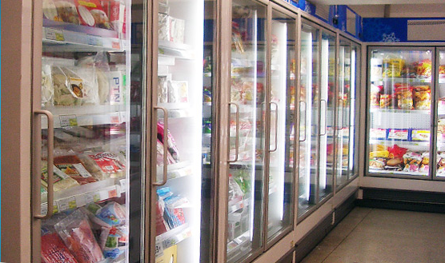 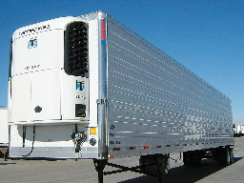

**Frigi-Tech Treatment amount**

|  |  |
| --- | --- |
| **Tonnage** | **Amount of Frigi-Tech** |
| 1- 10 tons | 1 Ounce per ton *(1 Oz = 29.57 ml.)* |
| 20 tons and greater | 5% -10% of the Oil capacity of the Compressor |

**Recommendation**

* + 5% application for units 5 years younger and
  + 10% application for units 10 years and older.

**Frigi-Tech History**

* Established in 1980’s by Clarence Adams (C.D.) with Rice University’s professor developing additive to extend the life of Air Conditioning Compressors.
* During the testing, there was a significant reduction of total KWH noticed.
* 1990’s : Frigi-Tech changed from preventative maintenance with energy savings being a side benefit, to the main benefit being reduced KWH consumption with a preventative maintenance side benefit.
* 2002 : Frigi-Tech enhance formula for compatible with all of newly Refrigerants.
* Frigi-Tech have expanded international sales over 50 countries.
* Frigi-Tech is backed by 2 Million USD international liability insurance policy that has never experienced a claim filed against.